**Module 4 Assignment — Module Four Project**

**Project: A Prescriptive Model for Strategic Decision-making, An Inventory Management Decision Model**

ALY-6050 Module four Project

**Prepared by: Sarvesh Thorve**

**Email: throve.s@northeastern.edu**

**INTRODUCTION**

**What is a Prescriptive model:**

A prescriptive model is designed to make solution easily understood. It gives problem solvers a solution that is very efficient and easy. Example of this analysis would be used in the transportation industry, for this industry to succeed cost effective delivery would be the major turning point. Minimizing energy usage through better route planning and solving logistical issues such as incorrect shipping locations can save time and money. To get a hold of all these issues, such businesses can automate and build a prescriptive model to provide recommendations.

**Strategic-Decision Modeling: -**

 Strategic decisions making is all about making the best decisions for the path of success. These decisions are important and are usually made by senior and top managers across organizations. Based on the nature of decision and other factors, their lifetimes and their effects may vary. For example a manager have to decide on the respective roles, communicate goals to the teammates or external stakeholders and account for uncertainties. The decisions he make not only impacts him but the organization as a whole.

In this project 4, inventory expenses are to be calculated for a manufacturing firm. In order to obtain low inventory cost which is our main focus in this project, we will have to add up the holding costs and ordering expenses, we will do it with the help of order quantities and order timing. The annual demand, unit costs, holding costs per unit, and costs per order were all given to us in the problem. We'll get the number of orders, the minimal total cost, the annual number of orders, from the next steps of the computation. This will help us make an offer to the inventory management suggestions.

**ANALYSIS**

**Part 1: -**

1. **Inventory Data: -**

In our data we have been given Annual demand and unit cost. In which the annual demand is uncontrollable parameter and the unit cost is a parameter model along with the orders placed. In our model we have decision variables as opportunity cost for the year, carrying cost per unit and the EOQ.

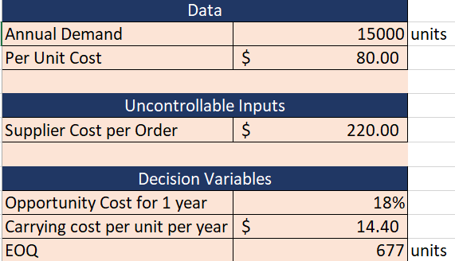

The total cost is calculated by adding the annual order, holding, total cost of annual demand costs.

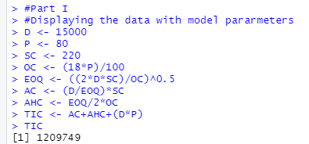

So we have the Annual demand for the firm D, Price per unit P and the cost of placing the order SC. With the help of these we find out Economic order quantity, Annual holding cost and annual ordering cost.

Demand annual/EOQ = annual orders.

* Data Tables: -

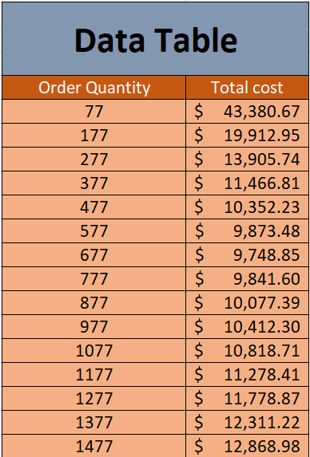

The table tells us that the lowest minimum inventory cost is $ 9,748.85 for the value of 677 order quantity.

* We plot a graph for both the quantities above:

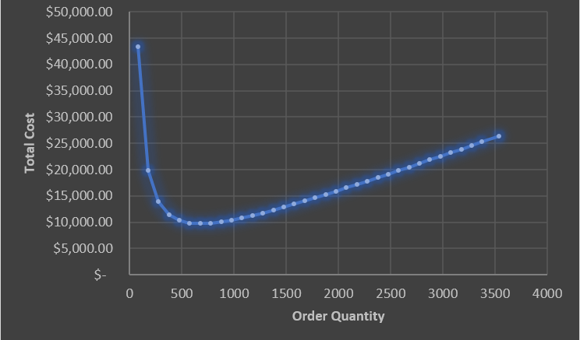

* Analysis Result :

The main objective of our analysis is to get the cost of inventory low as possible. In order for it to happen we need to make sure our inventory has a perfect amount of storage.it should not be less or more. We have found out that the economic order quantity of 677 gives us the minimum cost of inventory. If the quantity is reduced to 677, we should re-order twice the amount of inventory which is 1354.

**Part 2: -**

We first create 1000 simulations to verify the minimum inventory cost.

Then we use the triangular distribution:

The data above is normally distributed in our model so therefore Shapiro Wilk test is used to confirm it.

H0 – No difference between normal and irregular distribution.

H1 – Triangular shape is displayed

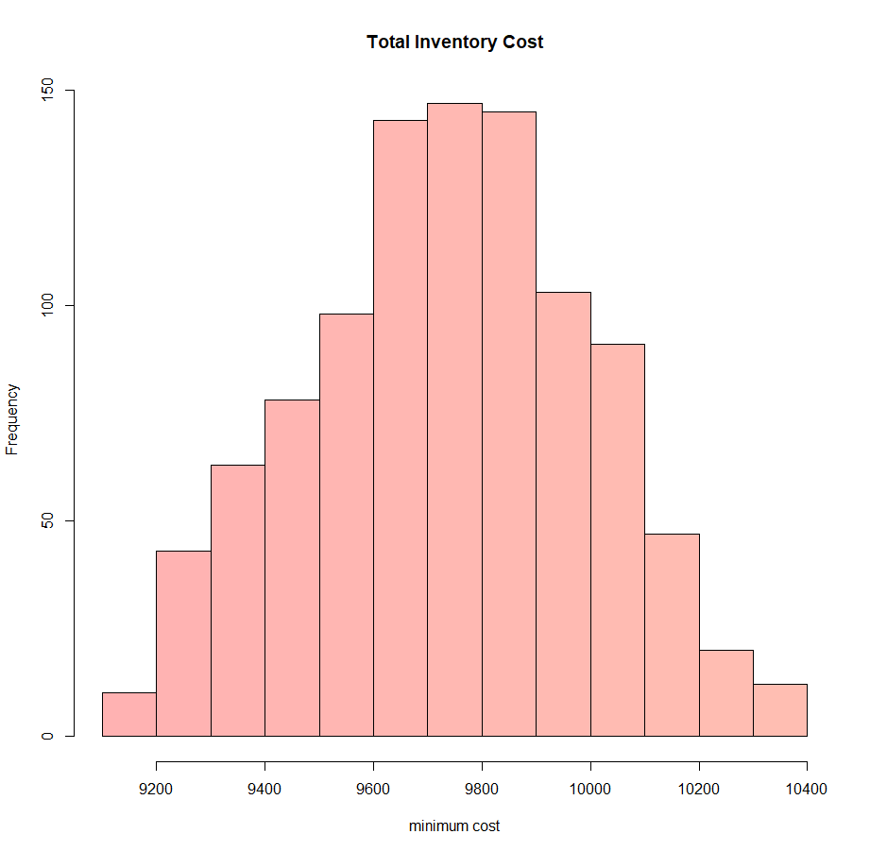

We need to do the shapiro test with a confidence interval of 95 percent in order to see whether the density plot is triangular or not.

* **To the Vice president :**

With the use of triangular probability, we make estimations on the amount of order received annually from the client. It can be estimated using annual test of orders. 1000 simulation which were tested can be repeated number of times as and when the demand. The company should take decisions on the basis of the triangular distribution.

**REFERENCES:**

* Northeastern.instructure.com. 2021. Log in - Loading Session Information.from <https://northeastern.instructure.com/courses/97774/pages/module-4-lab-1-a-minimizing-decision-model?module_item_id=6650424>
* Singh, S. (2018, August). Solving Basic Inventory Models Using Excel. Retrieved from <https://www.scirp.org/journal/paperinformation.aspx?paperid=86475>
* WHAT IS MANAGEMENT SCIENCE - AND PRESCRIPTIVE ANALYTICS? (n.d.). Retrieved from Frontline Solver: <https://www.solver.com/what-is-management-science>